

**HELP MATRICULATION CENTRE**

**MAY SEMESTER 2022**

**PROGRAMMING TEST**

(DOCUMENTATION)

**Subject Code :** FDPRG001

**Subject Name :** INTRODUCTION TO PROGRAMMING

**Student Name :** TOH EE LIN

**Student ID :** B2100948

Table of Contents

Cover page 1

Flowchart 3

*Main function* 3

*Other functions* 7

Pseudocode 8

Explanation for every segment of source code 12

Sample outputs when the program is executed 17

Testing for all valid inputs and negative test cases 20

*Age part* 20

*Proceed plan selection part* 22

*Choose a plan part* 22

*Choose a claim part* 23

# **Flowchart**

## ***Main function***

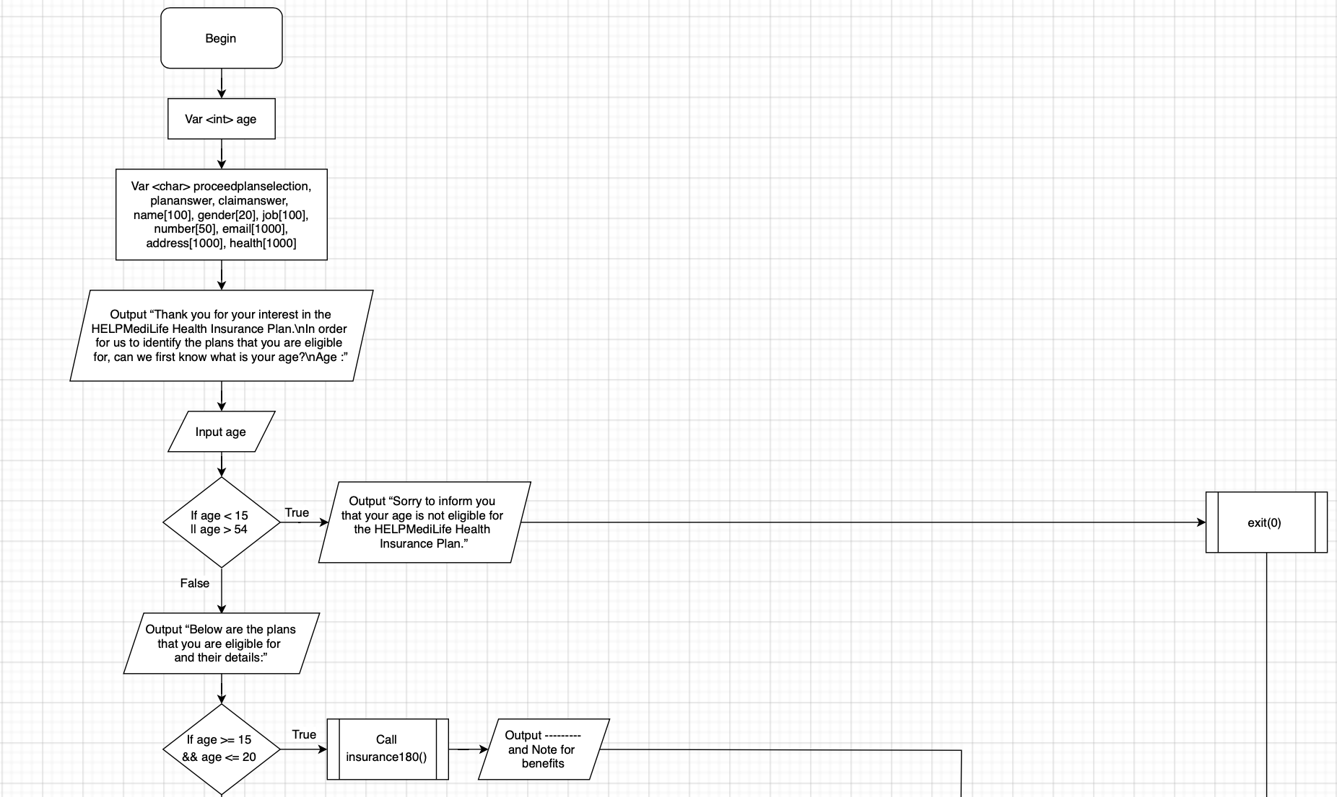

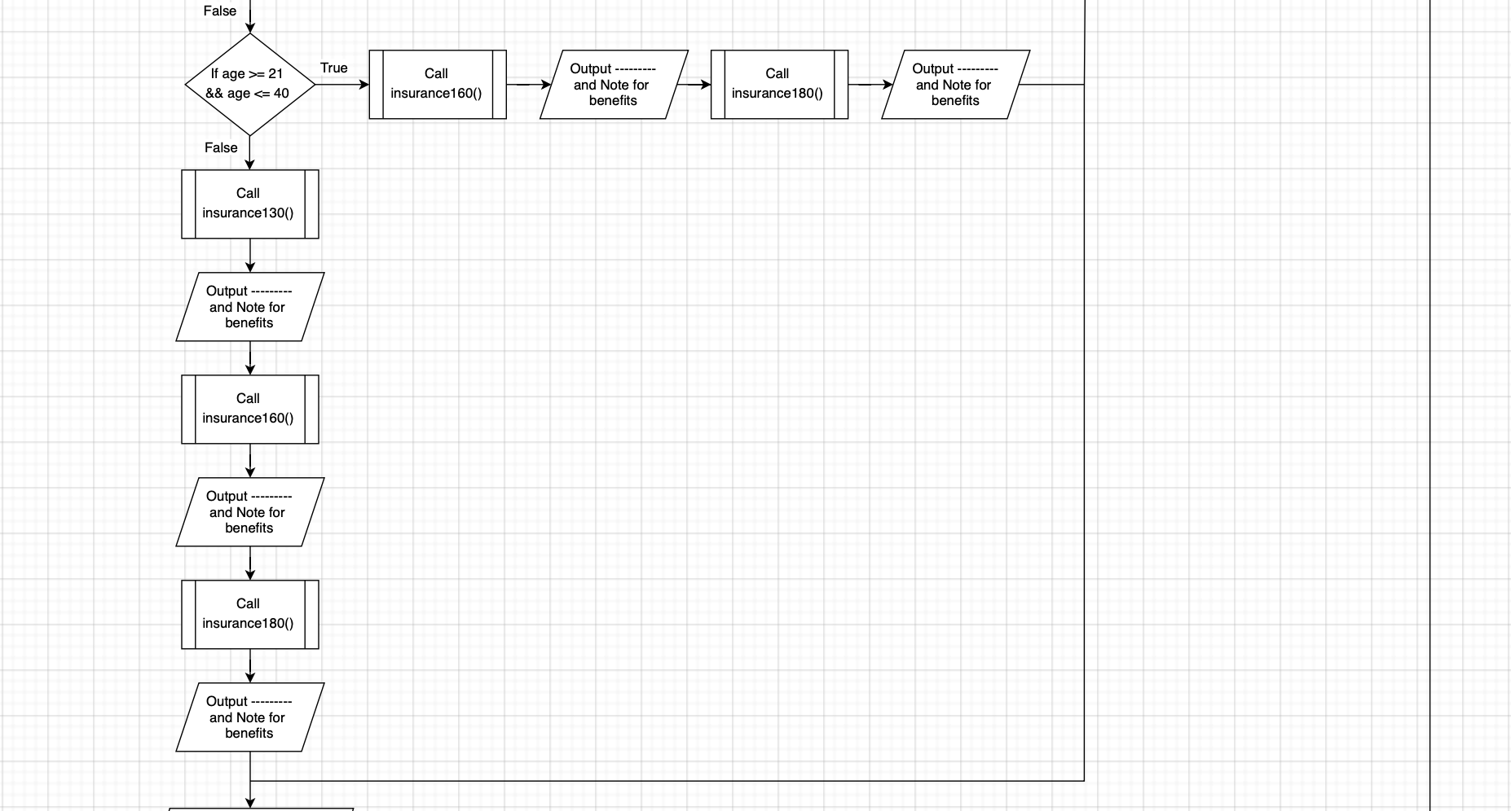

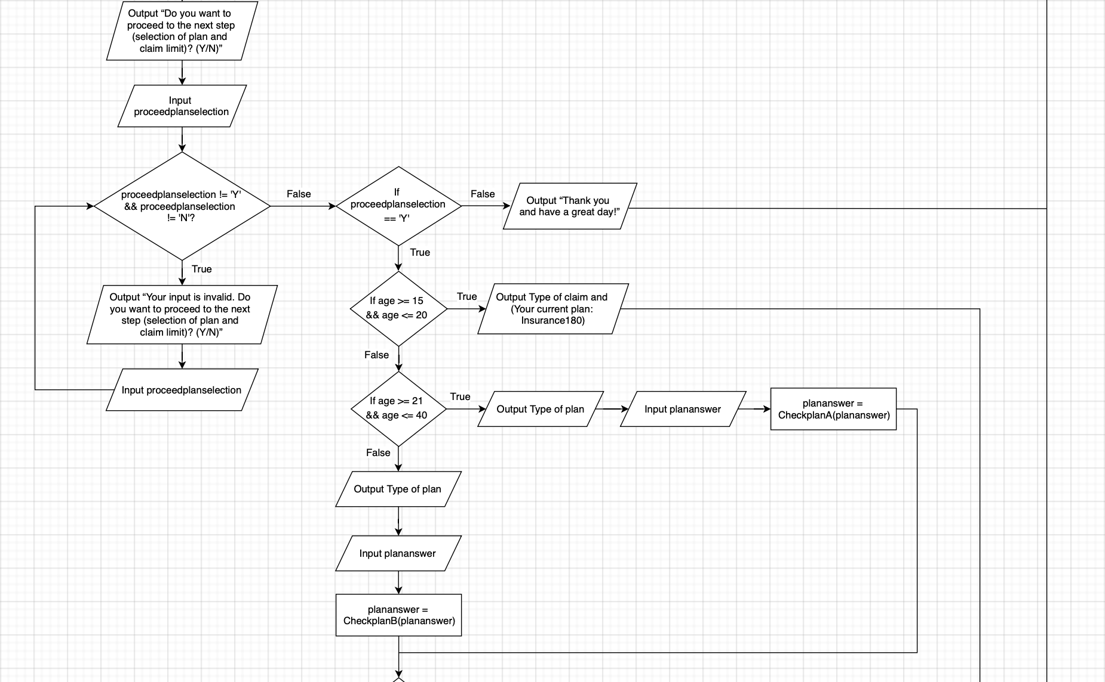

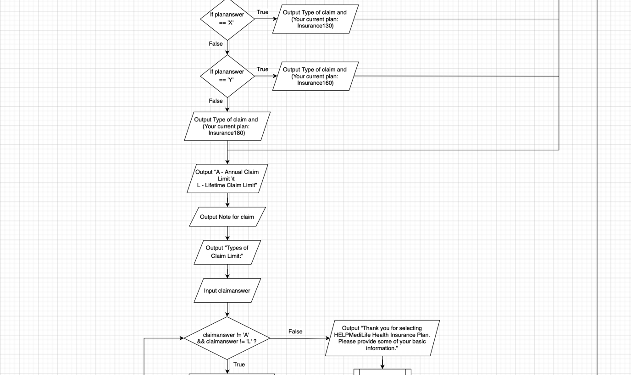

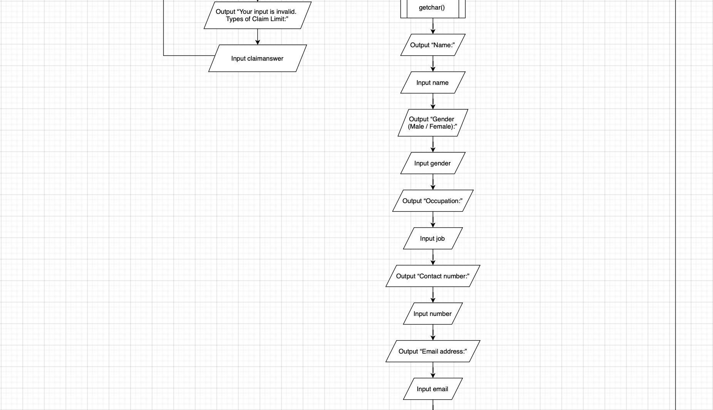

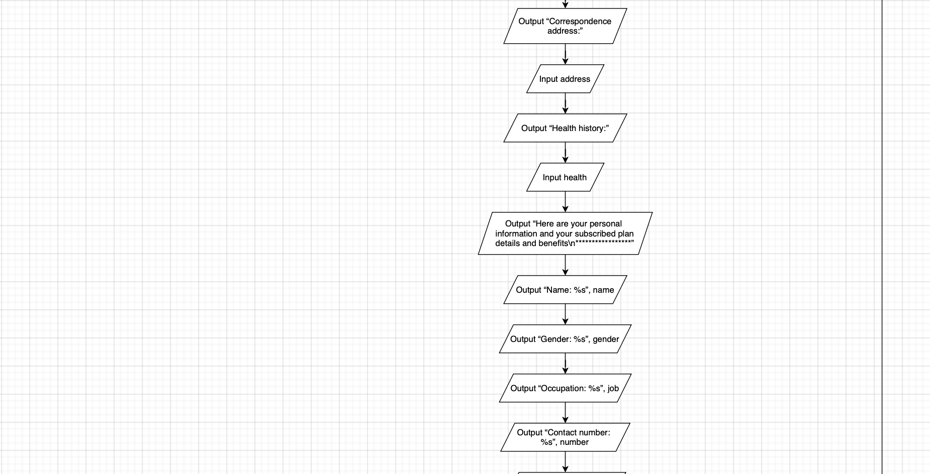

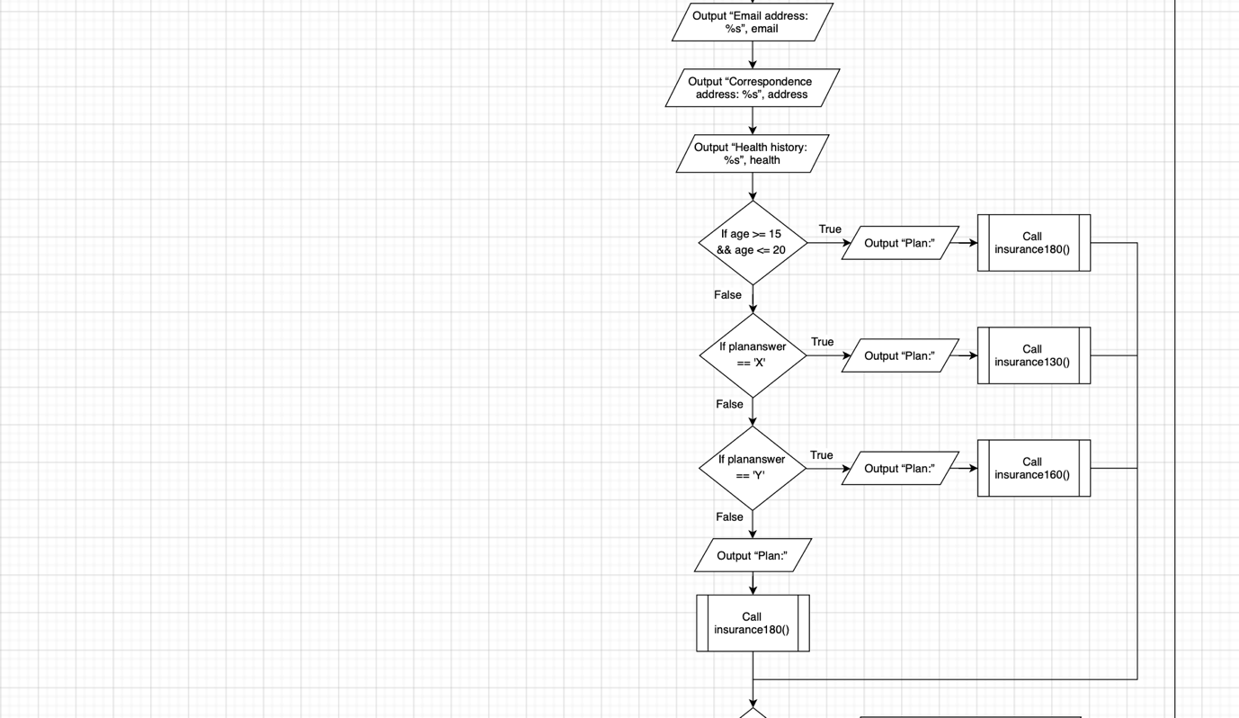

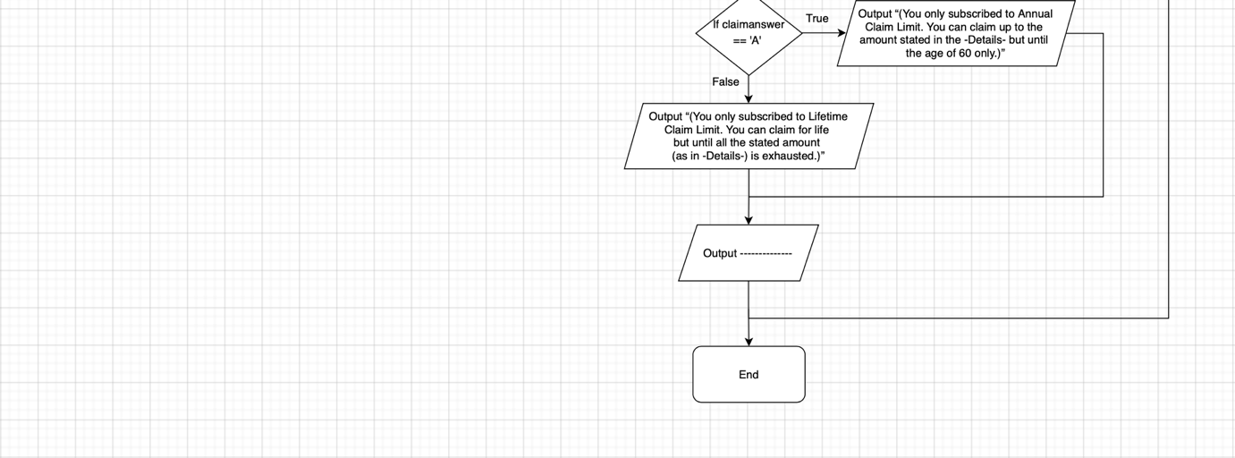

## ***Other functions***

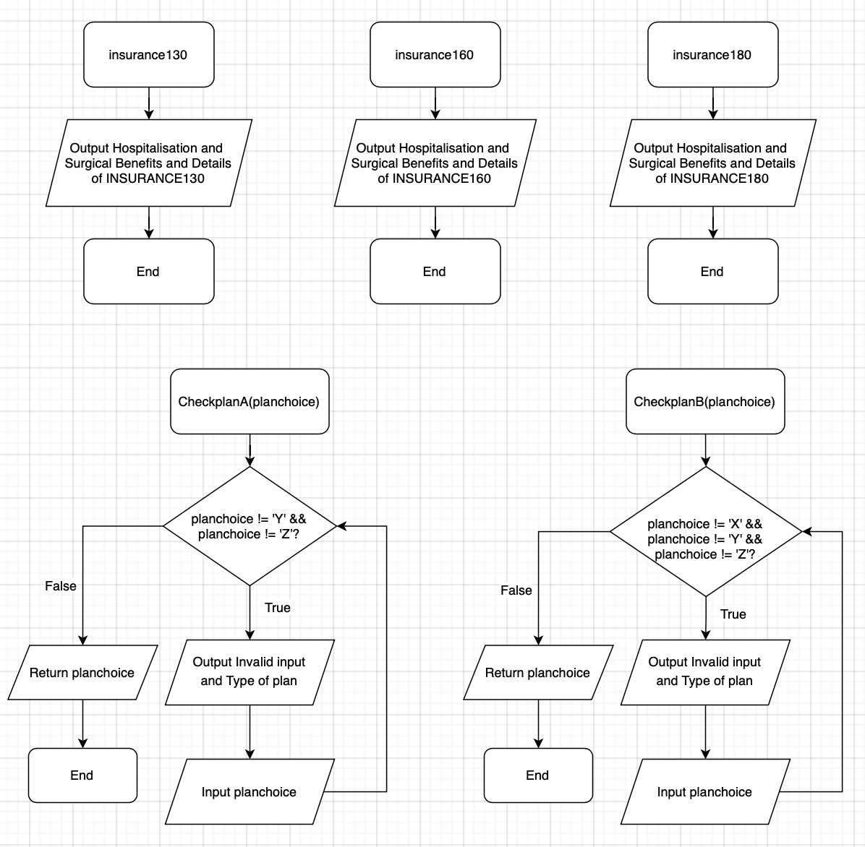

# **Pseudocode**

FUNCTION insurance130()

OUTPUT Hospitalisation and Surgical Benefits and Details of INSURANCE130

END FUNCTION insurance130()

FUNCTION insurance160()

OUTPUT Hospitalisation and Surgical Benefits and Details of INSURANCE160

END FUNCTION insurance160()

FUNCTION insurance180()

OUTPUT Hospitalisation and Surgical Benefits and Details of INSURANCE180

END FUNCTION insurance180()

FUNCTION CheckplanA(planchoice)

WHILE planchoice != 'Y' && planchoice != 'Z’

OUTPUT Invalid input and Type of plan

INPUT planchoice

END WHILE

RETURN planchoice

END FUNCTION CheckplanA(planchoice)

FUNCTION CheckplanB(planchoice)

WHILE planchoice != 'X' && planchoice != 'Y' && planchoice != 'Z'

OUTPUT Invalid input and Type of plan

INPUT planchoice

END WHILE

RETURN planchoice

END FUNCTION CheckplanB(planchoice)

BEGIN

VAR int age

VAR char proceedplanselection, plananswer, claimanswer, name[100], gender[20], job[100], number[50], email[1000], address[1000], health[1000]

OUTPUT “Thank you for your interest in the HELPMediLife Health Insurance Plan.\nIn order for us to identify the plans that you are eligible for, can we first know what is your age?\nAge :”

INPUT age

IF age < 15 || age > 54 THEN

OUTPUT “Sorry to inform you that your age is not eligible for the HELPMediLife Health Insurance Plan.”

CALL exit(0)

ELSE

OUTPUT “Below are the plans that you are eligible for and their details:”

IF age >= 15 && age <= 20 THEN

CALL insurance180()

OUTPUT --------- and Note for benefits

ELSE IF age >= 21 && age <= 40 THEN

CALL insurance160()

OUTPUT --------- and Note for benefits

CALL insurance180()

OUTPUT --------- and Note for benefits

ELSE

CALL insurance130()

OUTPUT --------- and Note for benefits

CALL insurance160()

OUTPUT --------- and Note for benefits

CALL insurance180()

OUTPUT --------- and Note for benefits

OUTPUT “Do you want to proceed to the next step (selection of plan and claim limit)? (Y/N)”

INPUT proceedplanselection

WHILE proceedplanselection != 'Y' && proceedplanselection != 'N'

OUTPUT “Your input is invalid. Do you want to proceed to the next step (selection of plan and claim limit)? (Y/N)”

INPUT proceedplanselection

IF proceedplanselection == 'Y' THEN

IF age >= 15 && age <= 20 THEN

OUTPUT Type of claim and (Your current plan: Insurance180)

ELSE IF age >= 21 && age <= 40 THEN

OUTPUT Type of plan

INPUT plananswer

plananswer = CALL CheckplanA(plananswer)

ELSE

OUTPUT Type of plan

INPUT plananswer

plananswer = CALL CheckplanB(plananswer)

IF plananswer == 'X' THEN

OUTPUT Type of claim and (Your current plan: Insurance130)

ELSE IF plananswer == 'Y' THEN

OUTPUT Type of claim and (Your current plan: Insurance160)

ELSE

OUTPUT Type of claim and (Your current plan: Insurance180)

OUTPUT “A - Annual Claim Limit \t L - Lifetime Claim Limit”

OUTPUT Note for claim

OUTPUT “Types of Claim Limit:”

INPUT claimanswer

WHILE claimanswer != 'A' && claimanswer != 'L'

OUTPUT “Your input is invalid. Types of Claim Limit:”

INPUT claimanswer

OUTPUT “Thank you for selecting HELPMediLife Health Insurance Plan. Please provide some of your basic information.”

CALL getchar()

OUTPUT “Name:”

INPUT name

OUTPUT “Gender (Male / Female):”

INPUT gender

OUTPUT “Occupation:”

INPUT job

OUTPUT “Contact number:”

INPUT number

OUTPUT “Email address:”

INPUT email

OUTPUT “Correspondence address:”

INPUT address

OUTPUT “Health history:”

INPUT health

OUTPUT “Here are your personal information and your subscribed plan details and benefits\n*****************”

OUTPUT “Name: %s”, name

OUTPUT “Gender: %s”, gender

OUTPUT “Occupation: %s”, job

OUTPUT “Contact number: %s”, number

OUTPUT “Email address: %s”, email

OUTPUT “Correspondence address: %s”, address

OUTPUT “Health history: %s”, health

IF age >= 15 && age <= 20 THEN

OUTPUT “Plan:”

CALL insurance180()

ELSE

IF plananswer == 'X' THEN

OUTPUT “Plan:”

CALL insurance130()

ELSE IF plananswer == 'Y' THEN

OUTPUT “Plan:”

CALL insurance160()

ELSE

OUTPUT “Plan:”

CALL insurance180()

IF claimanswer == 'A’ THEN

OUTPUT “(You only subscribed to Annual Claim Limit. You can claim up to the amount stated in the -Details- but until the age of 60 only.)”

ELSE

OUTPUT “(You only subscribed to Lifetime Claim Limit. You can claim for life but until all the stated amount (as in -Details-) is exhausted.)”

OUTPUT ----------

ELSE

OUTPUT “Thank you and have a great day!”

END

# **Explanation for every segment of source code**

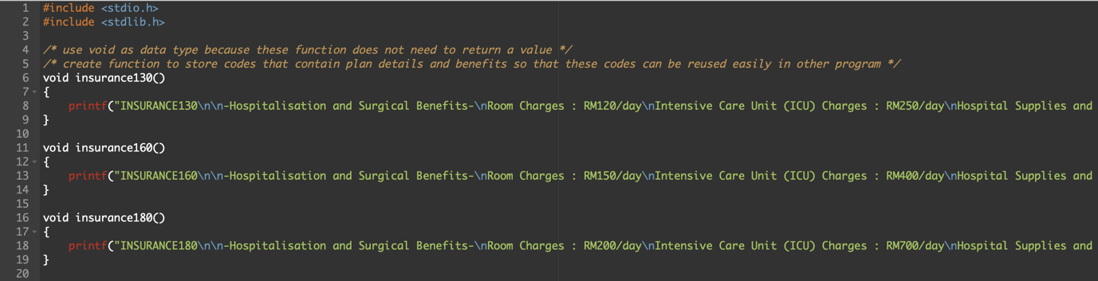

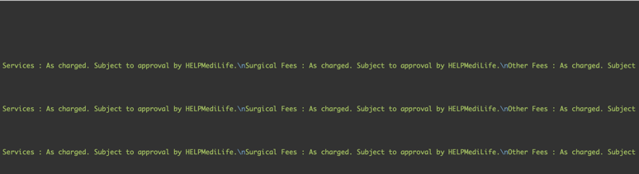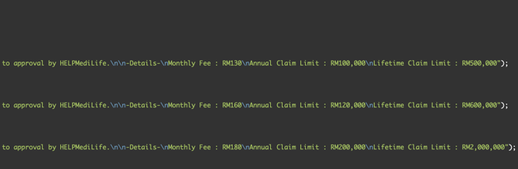

*\*Split into 2 screenshots because the code is long and cannot fit into screen.*

insurance130(), insurance160() and insurance180() are all functions that had been created to store the code that will display the plan details and benefits for INSURANCE130 plan, INSURANCE160 plan and INSURANCE180 plan respectively. These functions allow the reuse of codes that are inside these functions easily at other part of the program. Besides, void is used as the data type for these functions because these functions does not need to return a value. They just need to show the output.

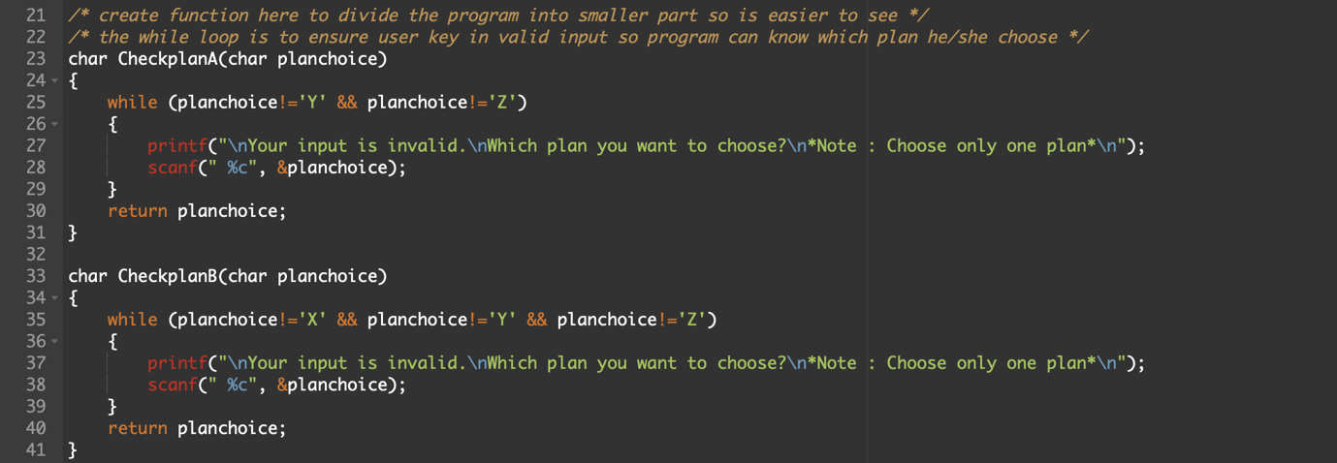

The codes inside these functions can be put inside the main function but they will make the main function looks messy. Hence, functions are created to store those codes. Both of these functions contain a while loop. These while loops are to ensure the user key in a valid input so that the program can know which plan he or she choose.

For function CheckplanA(char planchoice), if the user keys in alphabets other than Y or Z, the program will keep on ask the user to choose a plan (key in a valid input (either Y or Z)). Only until the user keys in Y or Z as his planchoice, the system will then return the planchoice to the main function. The same goes to function CheckplanB(char planchoice). The only difference is the function CheckplanB has 3 valid inputs, which are X, Y and Z.

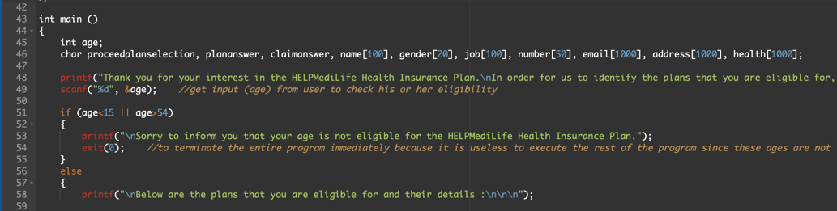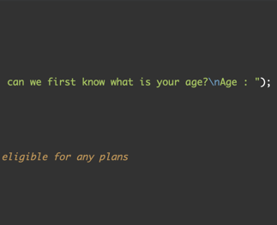

This is the main function. All the variables that are needed are declared. Firstly, scanf is used to get the user age. The age is needed to check his or her eligibility. Then, if else statement is used to execute particular code according to particular condition. In this case, if age is less than 15 or is more than 54, there is no plan for this age. Hence, exit(0) function is used to terminate the entire program immediately because there is no point to execute the rest of the program.

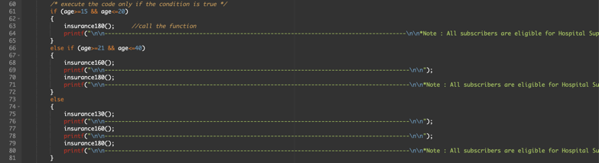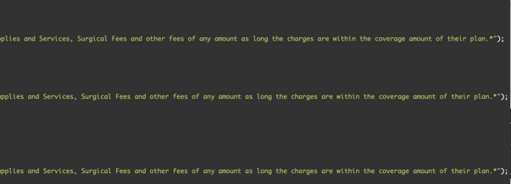

On the other hand, if age is more than or equal to 15 or less than or equal to 54, there is another if else statement to identify the user’s eligible plan. If user age is more than or equal to 15 or less than or equal to 20, the function insurance180() is called. *[can refer to explanation of function part]* The code that will display the plan details and benefits for INSURANCE180 will run and now user can see the plan details and benefits for INSURANCE180 on the screen. The same concept applies to other conditions.

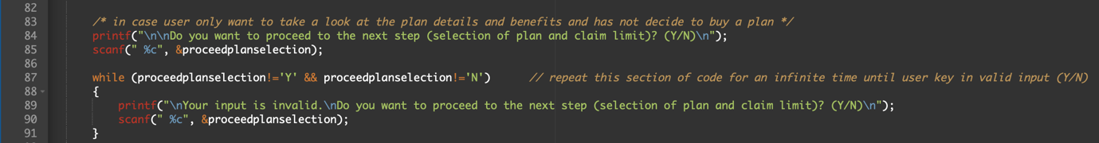

This scanf is to get user to key in either Y or N to let program know that whether he or she want to proceed to the next step. This is because there is possibility where user only want to take a look at the plan details and benefits and has not decide to buy a plan. A while loop is used to ensure the user key in valid input for proceedplanselection, which is either Y or N.

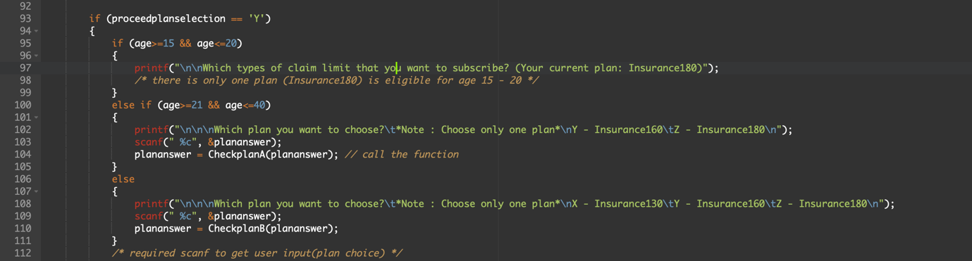

If user key in Y (want to proceed), there is another if else statement to help the program to identify the selected plan by user. In this case, if user age is more than or equal to 15 or less than or equal to 20, the program will straight away ask the user to key in the claim limit that he or she want because there is only one plan (Insurance180) is eligible for age 15 – 20. On the other hand, if user age is not within this range, a scanf is needed to get the plan choice from user. Functions CheckplanA and CheckplanB will also be called to check the validity of user input. *[can refer to explanation of function part]*

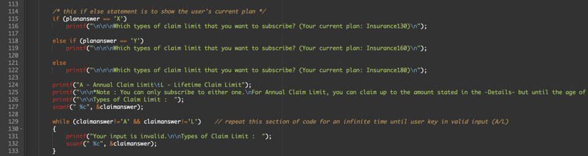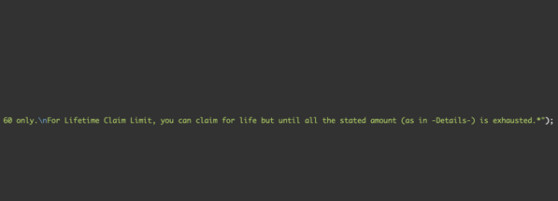

This if else statement is to display the user's current plan so the user no need to scroll up the program to see which plan he or she had selected (in case he or she forget).

The scanf is needed to get the claimanswer from user, which is either A or L. A while loop is used to ensure the user key in valid input (A or L) so that program can know which claim he or she subscribed. store the code that will display the plan details and benefits for

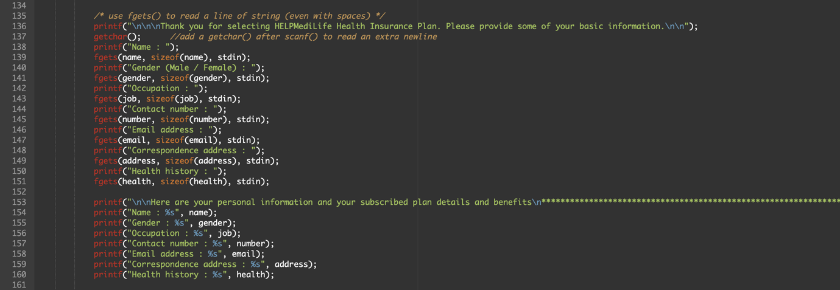

Function getchar() is used after scanf() (that has been used in previous section) in order to read an extra newline. This is needed because scanf() reads an integer and leaves a newline character in the buffer. So fgets() is able to read space and then fgets() reads the newline that is created by scanf() and the string for name is ignored. If getchar() is not used, the program will later skip the name and jump to gender.

Here is to get the user basic information. Since user basic information such as name, address and others will normally contain spaces, hence fgets is used because fgets() can read a line of string (even with spaces). After that, printf is used to display all the user basic information.

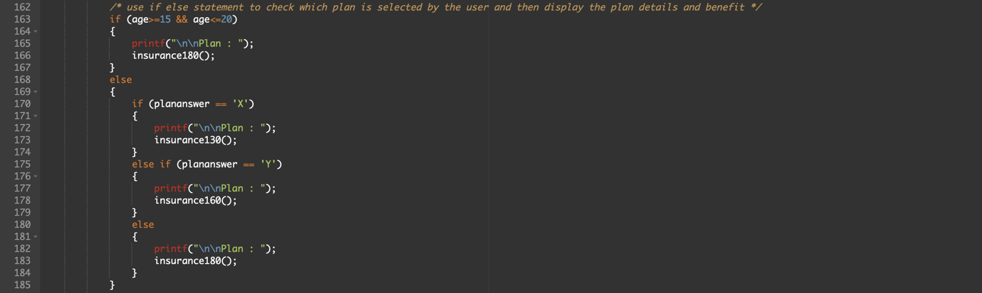

If else statement is used to check which plan is selected by the user and then display the plan details and benefit by calling the functions. These functions store the code that will display the plan details and benefits for particular insurance plan.

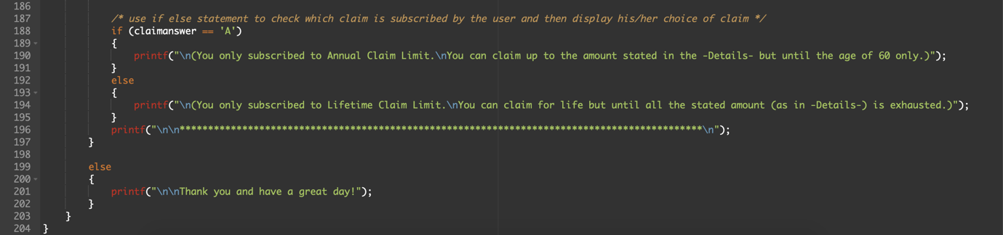

If else statement is used to check which claim is subscribed by the user and then display his or her choice of claim by using printf.

The last else is continue from the earlier if part, where the program ask user whether want to proceed to the next step or not. So, the else part here shows the results when user key in N (does not want to proceed). In this case, the program will display “Thank you and have a great day!” by using printf.

# **Sample outputs when the program is executed**

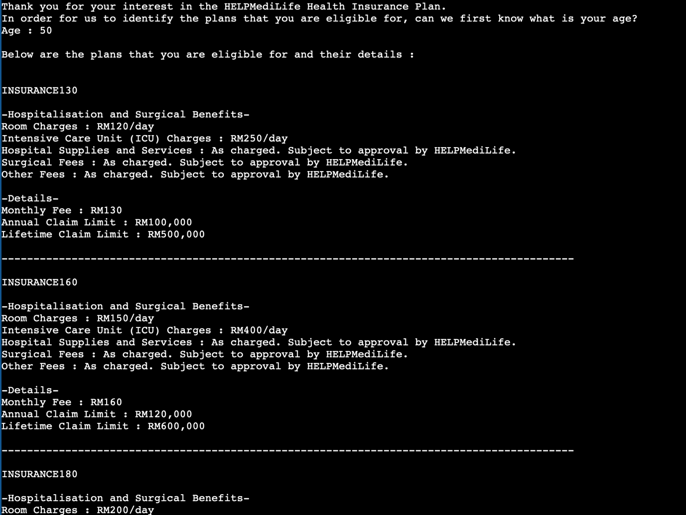

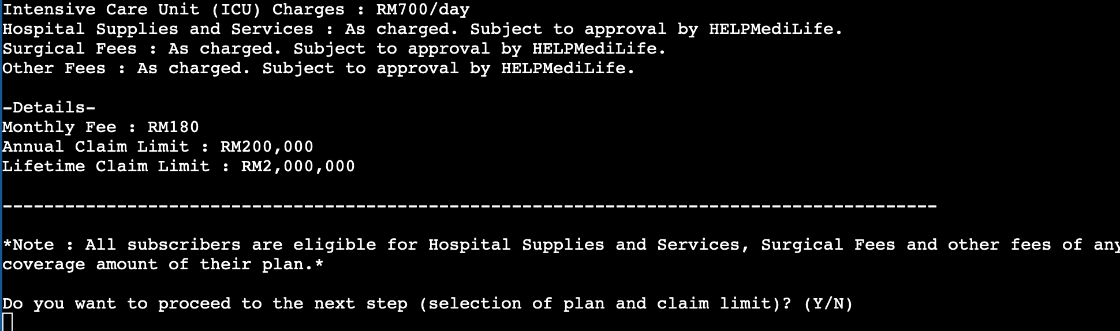

This is the sample output when user key in 50 as his or her age. Since 50 is an age which has eligible plans, the program will now show the plans that are eligible for this user. There are 3 plans being shown, which are INSURANCE130, INSURANCE160 and INSURANCE180. Hence, this shows that user who is of 50 years-old are eligible for these three plans.

After showing all the eligible plans, the program now ask the user whether he or she want to proceed to the next step, which is selection of plan and claim limit. The user can choose yes (Y) or no (N).

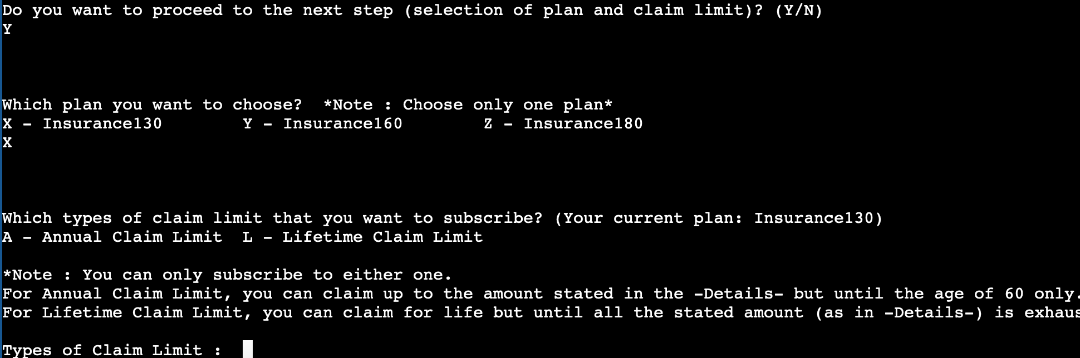

If the user key in Y, this means the user want to proceed to the next step. The program will now show all the plans that this user is eligible for and ask the user to choose a plan. The user is required to key in only alphabet that is stated in front of every plan.

After the user select the plan, the program will now show the claim limit types and ask the user to choose a claim limit. At the same time, user’s current plan is shown as well for user convenience.

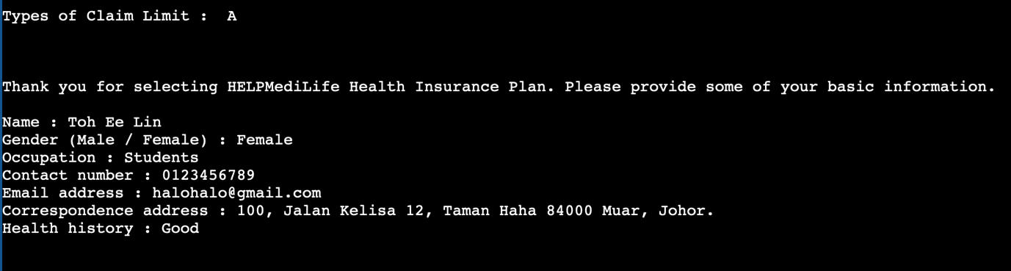

After the user choose a claim limit, the program will now ask for user basic information.

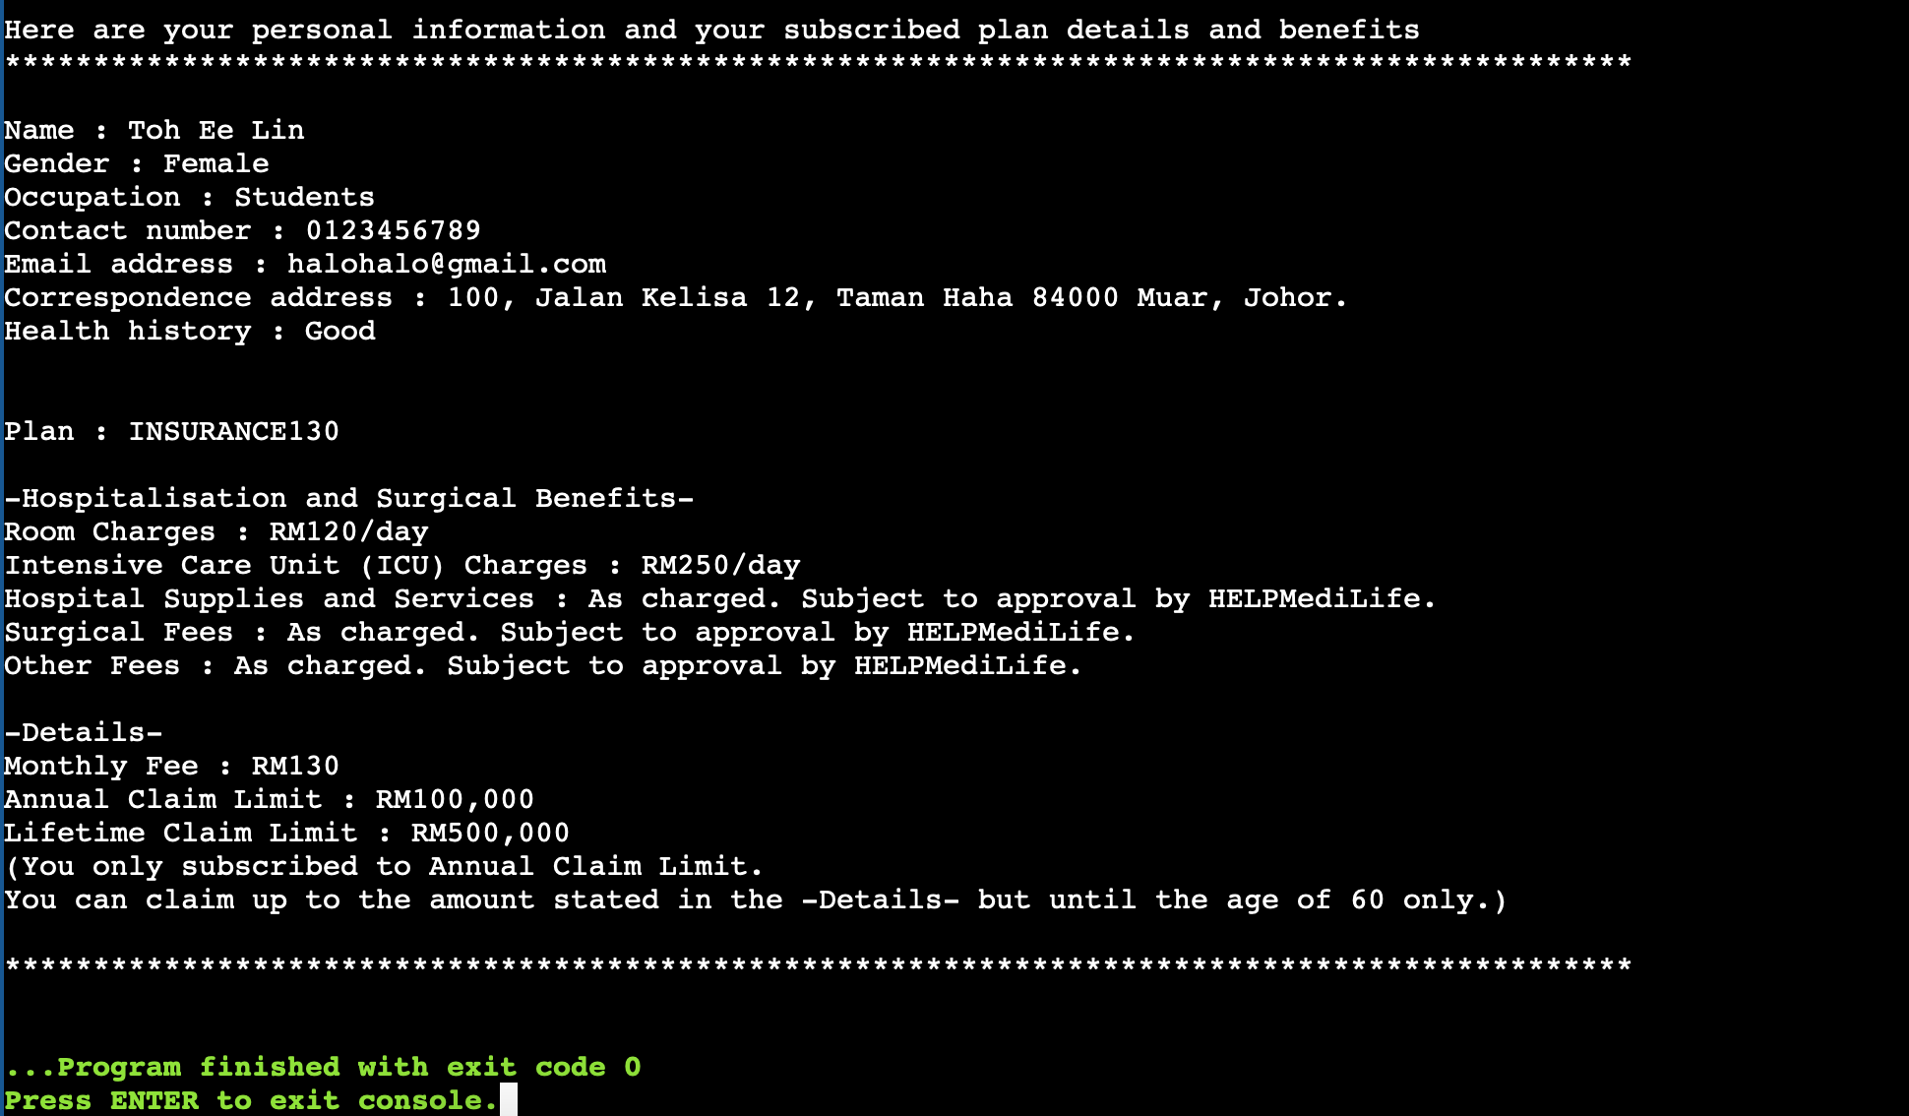

After the user finished key in his or her basic information, the program will now display the basic information that user key in just now and also the plan that he or she selected, followed by this particular plan’s detail and benefits as well as the claim limit that is subscribed by the user.

# **Testing for all valid inputs and negative test cases**

## ***Age part***

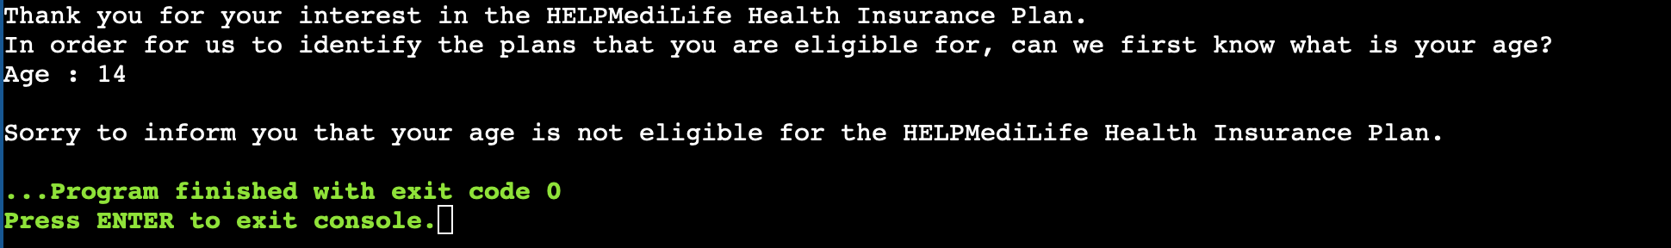

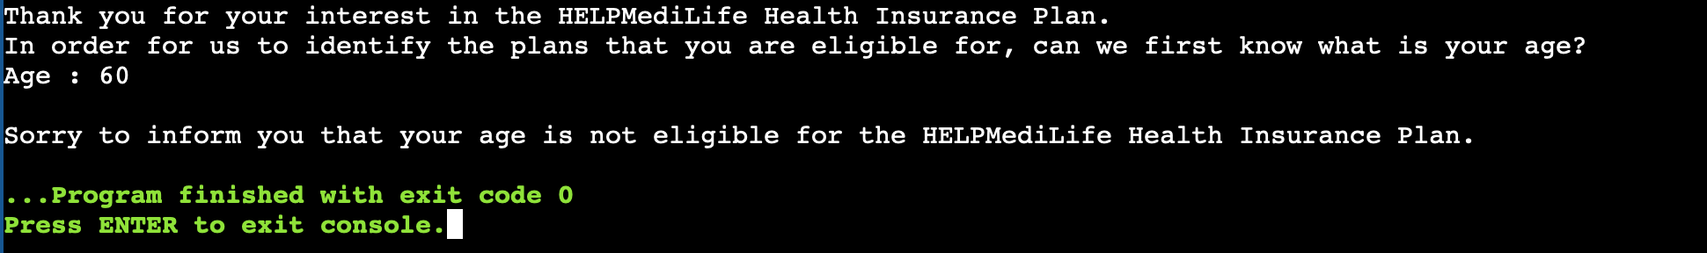

If the user key in age that is less than 15 **(such as 14)** or age that is more than 54 **(such as 60)** as his or her age, the program will show his or her age is not eligible for the HELPMediLife Health Insurance Plan.

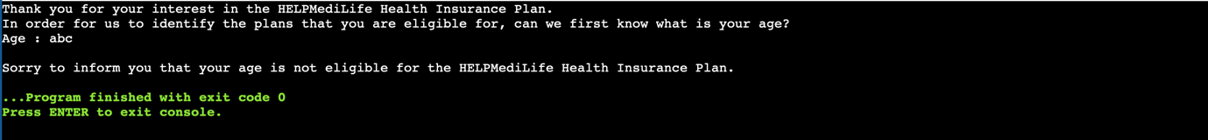

If the user key in invalid input **(such as abc)** as his or her age, the program will show his or her age is not eligible for the HELPMediLife Health Insurance Plan.

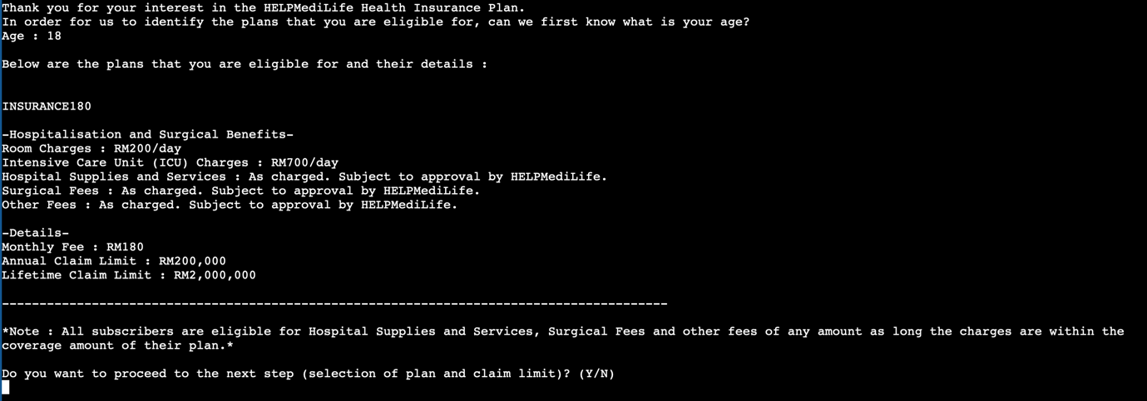

If the user key in age that is more than or equal to 15 or less than or equal to 20 **(such as 18)**, the program will show the only eligible plan (INSURANCE180) for him or her.

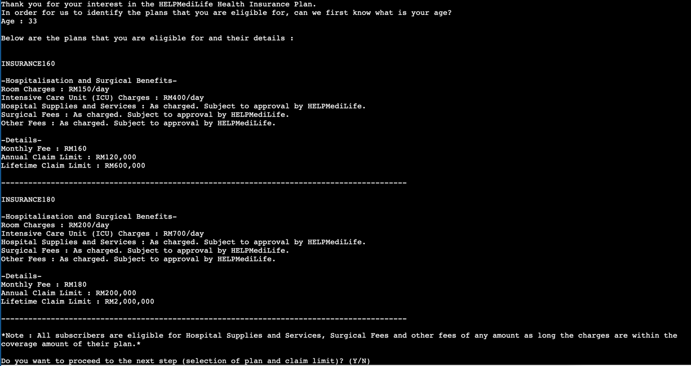

If the user key in age that is more than or equal to 21 or less than or equal to 40 **(such as 33)**, the program will show the eligible plans (INSURANCE160 and INSURANCE180) for him or her.

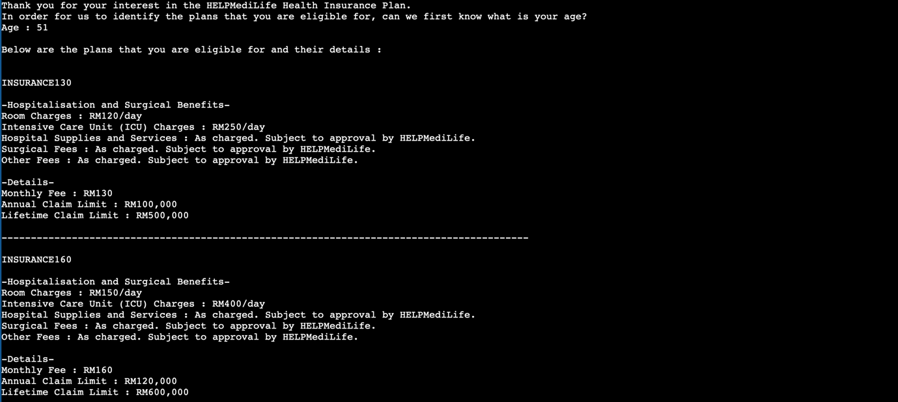

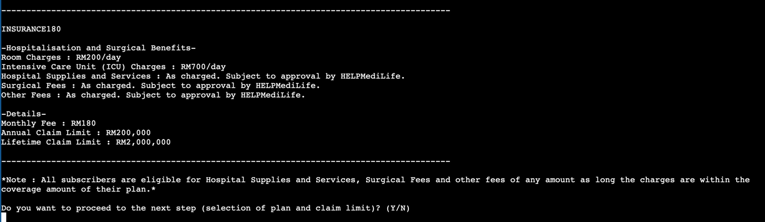

If the user key in age that is more than or equal to 41 or less than or equal to 54 **(such as 51)**, the program will show the eligible plans (INSURANCE130, INSURANCE160 and INSURANCE180) for him or her.

## ***Proceed plan selection part***

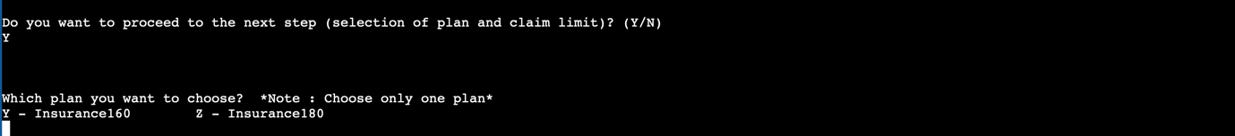

If the user key in Y, the program will then proceed to ask the user to choose a plan.

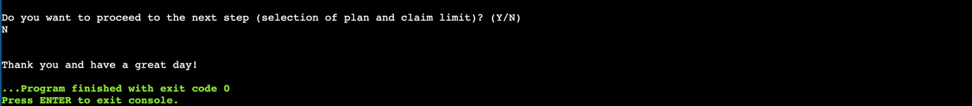

If the user key in N, the program will then display “Thank you and have a great day!” and end the program.



If the user key in 8, which is an invalid input, the program will then display “Your input is invalid” and ask the user to key in again.

## ***Choose a plan part***

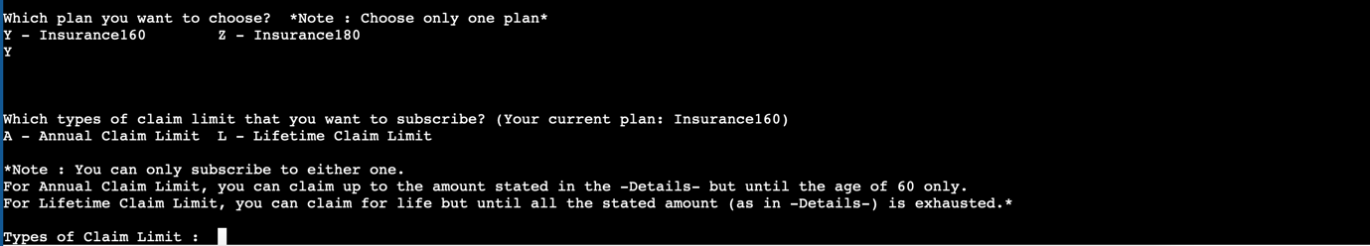

If the user key in Y, which is a valid input, the program will then ask the user to choose a claim and at the same time, the program will show the user’s current plan.

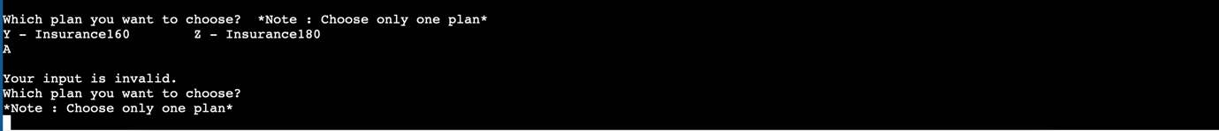

If the user key in A, which is an invalid input, the program will then display “Your input is invalid” and ask the user to key in again.

## ***Choose a claim part***

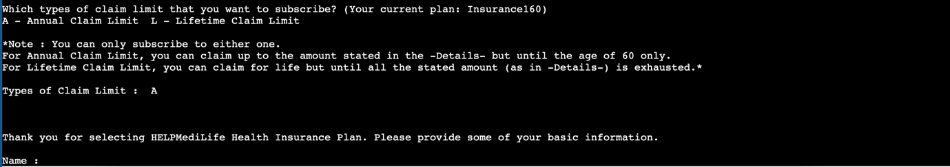

If the user key in A, which is a valid input, the program will then ask the user to fill in basic information.

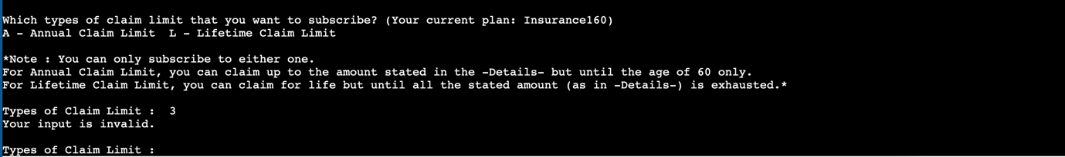

If the user key in 3, which is an invalid input, the program will then display “Your input is invalid” and ask the user to key in again.